Assignment – Risk assessment, maintenance checks and handover
Consider the following scenario: You are working in a busy gym and during your supervision of the gym floor, you are on the lookout for possible hazards that might pose a risk to customers, staff, and other visitors.

TASK 1
Identify four hazards in the image below (circle as appropriate).
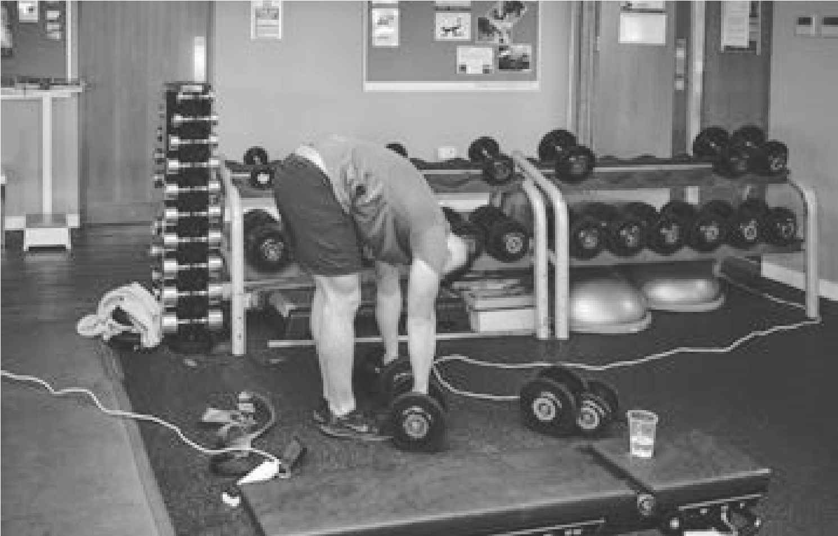

TASK 2
Choose one of the hazards identified in task 1 and complete a risk assessment:
- Identifying the five stages of a risk assessment.
- Relate them to the identified hazard.
- Explain how the risk of the hazard can be eliminated or reduced.
Risk-assessment stage (identify each one) | HAZARD
1.
2.
3.
4.
5.
How should the risk be managed?

TASK 3
Complete a maintenance checklist identifying the faulty equipment from the image below.
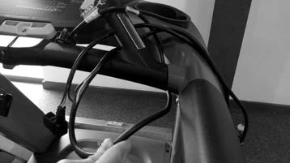
Piece of equipment | Yes/ no | What is wrong? | Action to be taken | Instructor initials
Equipment:
Electronic display is clear
All buttons are working
Treadmill belt is moving smoothly
Stop clip and button are working
Power cable is hidden away and free from damage
Plug is free from damage
Seat adjustments are secure

TASK 4
Complete a written handover to pass onto the next fitness instructor on shift. In addition to the faulty equipment, you need to make him/her aware of:
- An induction that is booked in at 11am.
- A class that has been cancelled at 10.30am.
- What has and has not been cleaned during your shift.

Assignment mark scheme – Risk assessment, maintenance checks and handover
Did the learner complete the tasks, to include: | Possible marks | Actual marks
1. Task 1 - Identifying hazards? | 4  (Minimum 3 marks)
2. Task 2 - Risk assessment? | 12  (Minimum 9 mark)
3. Task 3 - Maintenance checklist? | 2  (Minimum 1 mark)
4. Task 4 - Handover? | 3  (Minimum 2 marks)
Total / 21 marks (17 marks in total, with the minimum set marks achieved for each question required to pass)
Pass/Refer
Assessor’s feedback:

